By: Emma Sahl 9a 020327

Titel

Writer



Robert is also known as Bob. He was a shy and quiet boy in school, who didn´t have any big talents in other subjects than English, art and cricket. He didn`t finish school, he dropped out when he was at the age of fifteen. He started to work and try different things. Today he is a full-time writer and lives with his wife Brenda in Yorkshire Moors. Robert won the childrens award for a second time in 1990 with Room 13, and in 1994 he won a price for Stone cold.
(source: http://www.4learning.co.uk/bookbox/authors/swindells/index1.htm)

Story: Link is 17 and lives at home in Yorkshire with his mom and her new boyfriend, Vince who is a real swine. He always start argueing with Link. One night Vince locks him out, so he goes to his older sister, Carole, she lives on the same street as Link. She lives with her boyfriend, Chris. Link may spend the night at his sisters place but he notice that her boyfriend doesn`t like him so he goes back home home early in the morning.
On Christmas Eve Link gets a sleeping-bag for Christmas present, and as always, Vince and the Chris start argueing about Link, so he sneeks out with his sleeping-bag. Following day he decides to go to London. In London he rents a little filthy room from a rude guy, Link calls him Rat face, because he looks like a rat. How ever he take to much pay and then kicks Link out on the street. Link tries and tries to get a job, but it doesn`t go so well.
On his first night outdoors, he meets Ginger, a dosser. Ginger and Link become friends. At the same time you as the reader, get to know a mad and mystical man, an old military, a murderer!!! He introduces himself as Captain Hook. He fools dossers to come home to his house, where he murders them and puts them into his army of dead dossers. After about a month, Ginger vanishes. Link notices the military man and keeps away from him. Then he meets Gail, a female dosser. They become friends and start hanging out together. When Ginger dosen`t come back, they start searching for him. Link wants to check the house of Captain Hook, but Gail doesn`t want to come along. She goes to the police instead. Link passes by the house where Captain Hook lives, when suddently a voice invites Link to come in and have a warm meal and a coat. It was the voice of Captain Hook! Well inside the house Captain Hook starts to setting his plan into work. At last he has his victim, as he so long spioned at. Several times Link screames for help. Captain Hook forces Link to look at his army of Links dead friends, there among Ginger. They are all balled and wear army-clothes. Link pukes. In the last second when Captain Hook tries to strangle Link, the police come in.
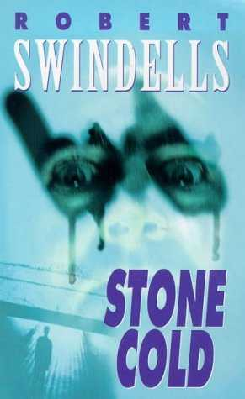
The whole story ends when it shows out that, Gails is not the one Link expects her to be. Gail is now under the name, Louise Bain, a reporter, who writes articles about homeless people, and then, by an event she discoveres the murderer. Of course Link feels used and dissapointed, after all, he thought Gail and he were friends. Good friends.

